MARYAM BORUMAND

Running for PRESIDENT OF KEELE POSTGRADUATE ASSOCIATION

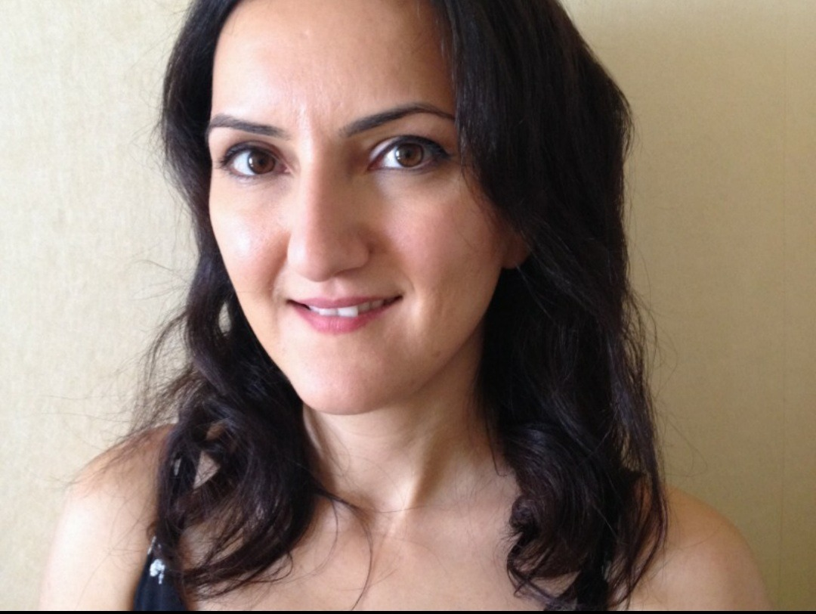
About me

I am a postgraduate student, studying Clinical Education. I enjoy swimming, coffee and eating lots of salad. I am full of energy and always have to be doing many things at the same time. I’m never afraid of a challenge…actually I laugh at the face of a challenge because nothing phases me!

I am an all-rounder as I have both previous degrees and work experience. In my previous degree, I was a student representative for my course and attended Student and Faculty Committee meetings. I then relayed the outcome from the meetings to the students.

I have attended conferences both in UK and abroad and even presented in some of them. I have passion for listening and helping people feel better. Having worked as a Physician Associate in General Practice, I have developed excellent interpersonal skills.

I have gained valuable work experience over the years in the Clinical Research industry. That has taught me time management as I worked on a number of projects simultaneously, teamwork and leadership skills. During my first degree I worked part time as sales assistant in retail, which helped me develop excellent organizational skills.

Good communication skills, developed through lab and departmental presentations, as well as demonstrating in undergraduate practicals and private tutoring, enable me to correspond well with people at all levels. In extension, studying a PhD and my work experiences, have provided me with the opportunity to develop professional skills.

I am a keen volunteer and have participated in numerous fundraising events including a tandem jump with UK PARACHUTING to raise money for cancer research and a 'Fire Walk' event to raise money for the blind.

I am fluent in English. I can speak little French and Spanish. I can also understand Turkish.

Why I’m running

I am a big believer of justice and fairness. Education is my passion. I want to make sure all postgraduates receive a great education from Keele University. To do this, we need readily accessible support, and available resources.

I know I can do a good job because I am super confident. I say it exactly as it is, and I make sure I fully represent students’ voice. I have studied at other universities so I can implement ideas that I know will work well. Also, I am familiar with university regulations.

I understand student engagement is an important part of learning process. Lack of engagement can mean students will struggle in their studies, so I want to make sure this never happens.

Students with disabilities need reasonable adjustments. I understand what students go through and being aware of the regulations, I want to ensure there is adequate reasonable adjustment plan.

I understand that university life is a journey of self-development and Continuing Professional Development. I believe it is never too late to try and achieve your goals and dreams, and that is what I want every postgraduate student to believe.

My priorities

- Ensure postgraduate students are kept up-to-date with developments on COVID-19 restrictions and its impact on return to campus
- Learn about postgraduate student views through regular surveys, and identify areas which require improvement
- Evaluate current academic support offered and see how it can be improved
- Introduce a mentorship programme and possibly get potential employers involved
- Set up a focus group with postgraduate students from different courses and find out how teaching can be improved
- Develop the postgraduate committee
- Ensure postgraduate student views are considered for curriculum development

